Herbicide applications do not immediately affect phylogenetic structure of plant communities in Benin City, but for how long?

It’s only a matter of time: herbicide application affects phylogenetic structure of plant communities in Benin City

**ABSTRACT**

Herbicides influence plant communities by differentially affecting species’ survival, growth, and recovery, thereby altering their composition. While some species quickly show resilience or re-establish after herbicide exposure, others fail to. Here, we investigated the effects herbicides application on phylogenetic structure of plant communities in an unmanaged grass lawn in Edo State, Nigeria. ………..was sprayed with a glyphosate-based herbicide (Forceup™), and plant ground cover was monitored for 11 weeks, spanning a late dry season to an early wet season. Phylogenetic signal was measured using Blomberg’s K statistic before spraying, immediately after, and during recovery. Herbicide application caused a significant reduction in plant cover (-92.1%, p < 0.05) but did not immediately affect the phylogenetic structure of the community (p > 0.1). The phylogenetic signal significantly declined as the plant community recovered, indicating increasing phylogenetic divergence. This pattern suggests that competition, rather than resilience to herbicide, shaped community reassembly by disproportionately favouring distantly related species over closely related competitors. These findings highlight the role of competition in driving phylogenetic divergence following disturbance and have implications for sustainable weed management.

**Keywords:** Herbicide resilience, phylogenetic conservatism, Competition, recovery, ground cover.

**INTRODUCTION**

Herbicides shape plant community dynamics by differentially affecting species' survival, growth, and recovery, thereby altering their taxonomic and functional composition (Grundy et al., 2011; Wange et al., 2016; Iriart et al., 2021; Briggs et al., 2025). Some species demonstrate resilience and recover rapidly after herbicide exposure, while others fail to re-establish (Powles & Yu, 2010; Burns & Strauss, 2011; Gratani, 2014; Iriart et al., 2021). Environmental conditions, resource availability, and species-specific phenotypic traits may influence these differential responses (Helmus et al., 2010; Iriart et al., 2021; Délye et al., 2013; Gratani, 2014; Kumordzi, 2015; Fritschie et al., 2014; Violle et al., 2011). However, the extent to which evolutionary history shapes these responses amidst other competing factors is still debated For example, Wang et al. (2016) found that functional traits, not phylogeny, explained phytoplankton responses to glyphosate. Conversely, Gibson et al. (2019) reported that triclopyr and fluroxypyr reduced phylogenetic divergence in plant communities, suggesting herbicides may filter for closely related species. Some studies suggest responses to environmental stress depend on whether species are primarily native or introduced (Quain & Sandel, 2017; Manish, 2021; Menalled et al., 2023).

Phylogenetic conservatism, the tendency of closely related species to share similar ecological traits and niches due to their shared evolutionary history (references), is important to understanding species assembly and diversity patterns. Closely related plant species often share phenotypic traits, which could result in similar levels of resilience or susceptibility to disturbance (Losos, 2008; Helmus et al., 2010; Schoener, 2011; Cavender-Bares & Reich, 2012; Violle et al., 2011; Godoy et al., 2014). However, a counterargument can be made: closely related species may not exhibit similar responses to anthropogenic activities if intense competition among them negatively impacts their coexistence at the local scale (Violle et al., 2011; Fritschie et al., 2014; Godoy et al., 2014; Naughton et al., 2015). This is largely due to Darwin’s (1859) suggestion that species sharing close evolutionary relationships are more similar and compete more intensely with one another than with more distant ones. This phenomenon is referred to as the competition-relatedness hypothesis and is supported by the theory of limiting similarity, which emphasizes that species must differ in their ecological niches to coexist locally (MacArthur & Levins 1967; Abrams, 1983). If co-existing species are too phylogenetically alike, the one with a competitive disadvantage will be driven towards depletion (or a worst case: extinction) due to competitive exclusion (Hardin, 1960; Jaeger, 1974; Johnson & Bronstein, 2019; Levin et al., 2020). As a result, competition among closely related species may counteract phylogenetic conservatism. If related plant species experience stronger competition with one another than with more distantly related species, herbicide resilience within a closely knit clade could lead to intense intra-clade competition, ultimately favouring the persistence of more distantly related species. Thus, competition may drive divergence in herbicide resilience.

Despite extensive research on plant-herbicide interactions, the role of phylogenetic relatedness in shaping plant species’ responses to disturbances from herbicide application remains understudied (but see Wang et al., 2016; Gibson et al., 2019; Iriart et al., 2021; ). Understanding whether plant responses to herbicide application—survival and/or recovery—are phylogenetically conserved (or not) can provide valuable insights into community assembly and species coexistence in disturbed environments (Violle et al., 2011; Germain et al., 2016; Zepeda & Martorell, 2021). Identifying the balance between evolutionary constraints and competitive interactions in shaping plant community responses can provide valuable insights for ecological management and conservation in both natural and human-influenced landscapes (Grundy et al., 2011; Pellissier et al., 2014; Lemos‐Costa et al., 2024).

This study aims to assess the phylogenetic conservatism of plant responses to herbicide application in an unmanaged lawn. Specifically, we determined whether closely related species exhibit similar survival and recovery patterns, as reflected in changes in their percentage ground cover over time. For this study, ground cover would be regarded as the living (green) plants as seen from a vertical aerial observation. In a dense grass community, the ground cover (%) is a good way to learn how much competitive space a plant species has (Anderson, 1986; Damgaard, 2011). In limited space, ground coverage is a zero-sum game; plants that take higher cover have more access to sunlight (and space) and also consequentially deprive other plants of these resources. If phylogenetic conservatism influences herbicide resilience, we expect closely related plant species to exhibit similar responses immediately following herbicide application, leading to increased phylogenetic clustering among surviving species. However, as ground cover increases during post-spray (recovery), competitive interactions may disrupt this pattern, leading to greater phylogenetic divergence over time. If competition structures communities, then the co-existing plants should be less related than expected by chance.

**MATERIALS AND METHODS**

**Study Site**

The study was conducted from February to April 2023 on an enclosed, unmanaged lawn behind Egborge Museum at the University of Benin, Benin City, Nigeria (longitude: 6.392° N, latitude: 5.613° E). The university is located in southern Nigeria, within a tropical rainforest environment. As shown in Figure 1, the site measures 23.77 m by 11.58 m. During the survey period, mean ambient hourly temperatures ranged from 25 to 34 °C (Accuweather, 2023).

**Experimental Design and Herbicide Application**

To allow for independent replication and to observe potential spatial autocorrelation, the study site was divided into six plots (A-F; Figure 1). Each plot contained six subplots, but data were aggregated at the plot level to reduce random noise. A subplot is a 1 m × 1 m area measured by an equally sized quadrant.

Before herbicide application, plant cover was surveyed as a baseline (week 0). The entire study site was then treated with a non-selective systemic herbicide, Forceup™, which contains glyphosate as the active ingredient. The herbicide was applied at the recommended rate of 6 L/ha using a manually pressurized, two-litre handheld sprayer, with a solution concentration of 48 mL of glyphosate per litre of water.

**Data Collection**

Plant cover data were collected over approximately 11 weeks, specifically at weeks 0 (pre-spray), 3, 7, 9, and 11. Cover was estimated on a scale of 0–100%, where 0% indicated that the plant was not visible from a vertical aerial perspective, and 100% meant that a plant species completely dominated the 1m × 1 m quadrat, with no visible ground. Dead or fallen leaves were excluded from the cover estimation. The survey concluded at week 11, as continued measurements became impractical due to some plant species reaching heights of up to 0.5 m, making ground cover estimation unreliable.

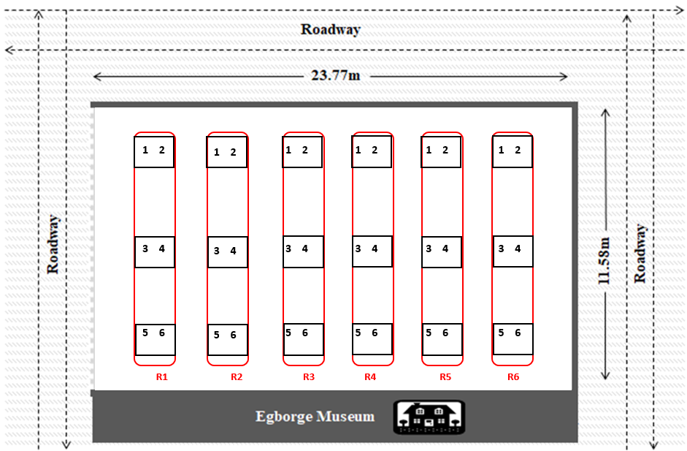

Figure 1: Schematic representation of the study site showing enclosure and boundary by concrete and outer tared roadside. Each plot (R1-R6) is coloured in Red. Six subplots within a plot, each numbered 1-6, with each number representing a 1m × 1 m quadrat area.

**Phylogenetic and statistical analysis**

Phylogenetic trees of the plants were assembled using the “V.PhyloMaker” R package. This package matches the taxonomic names of our study plant species to a backbone phylogeny derived from the Global Backbone of Tree for Biodiversity (GBOTB) with extended coverage (Jin & Qian, 2019). This approach allows for including species that may not be present in the reference phylogeny by placing them within their most likely evolutionary position. Phylogenetic distances were computed and matched with longitudinal percentage ground cover data. We tested for significant phylogenetic signal, relative to a random distribution of the traits observed, given the topology and branch lengths of the ML phylogeny, with 999 replicates. Blomberg’s K is used as a metric of phylogenetic signal, where K is calculated as the ratio of the observed phylogenetically correct mean-square error divided by the mean-square error of the data, standardized by the expectation under Brownian motion (Blomberg et al. 2003). K = 0 indicates no phylogenetic signal, 0 < K < 1 indicates that closely related species resemble each other less than expected under the BM model of trait evolution, K = 1 indicates phylogenetic signal as expected by BM evolution, and K > 1 indicates high phylogenetic signal, with closely related species resembling each other more than expected under BM (Blomberg et al., 2003). Welch’s t-tests (with equality of variance not assumed) was used to assess significant differences in the effect of spraying on [1] Blomberg's K values and [2] the plant ground cover (%) before and after spraying. Furthermore, an orthogonal polynomial mixed-effects model was used to examine the relationship between the plant’s ground cover (%) and the strength of the phylogenetic signal (measured using Blomberg’s K statistics). Plots were included as a random effect to control for variation due to repeated measurements. Analyses were conducted in R (version 4.4.0.1). All data sets and R script used in the analysis are present in a GitHub repository (<https://github.com/Nosa-Osawe/Phylogenetics/blob/main/Codes/Competition_phylogeny.R>)

**RESULTS**

All the plant species identified in this study represent 12 distinct species across 9 families, with their phylogenetic relationships illustrated in Figure 1. The plant species include: *Chromolaena odorata* (Asteraceae), *Asystasia gangetica* (Acanthaceae), *Ixora coccinea* (Rubiaceae), *Sida acuta* (Malvaceae), *Alternathera brasiliensis* (Amaranthaceae), *Panicum maximum* (Poaceae), *Emilia praetermissa* (Asteraceae), *Tridax procumbens* (Asteraceae), *Commelina erecta* (Commelinaceae), *Centrosema pubescens* (Fabaceae), *Leucaena leucophala* (Fabaceae), and *Eleutheranthera ruderalis* (Asteraceae).

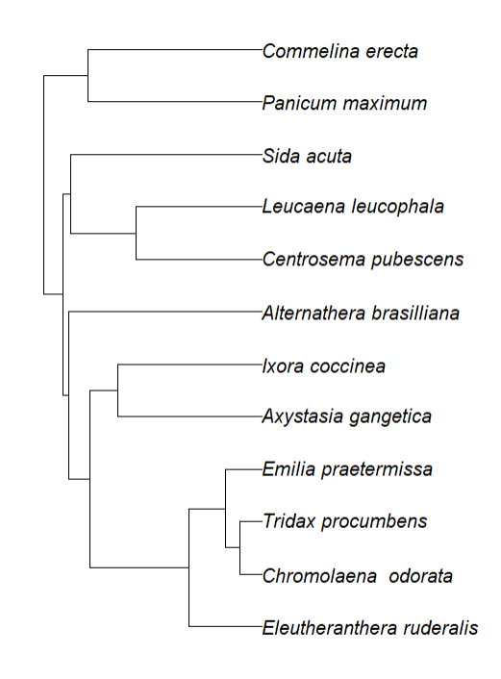

**Figure 1**: Phylogenetic tree showing the evolutionary relationships between the plants in the study.

Before herbicide spray (week 0), the plant cover was at 10.75±2.77% but reduced to 0.84±0.22% after the spray (in week 3). However, the plant responded positively with time, increasing rapidly up to 72.6±5.20% at the end of the survey (week 11), as shown in Figure 2.

The application of herbicide significantly (t= 3.54, p=0.016) impacted the ground cover (%) of plants, as seen in the reduction in cover between pre-spray and post-spray (week 3). However, this was not so with the phylogenetic signal, which did not change significantly (t= 0.46, p=0.661) between the pre-spray and the immediate post-spray period (week 3). This is so despite the high reduction (-92.1%) in the mean percentage of plant cover following herbicide application (Figure 2), indicating that the application of herbicide had no significant implication on the plant community’s apparent phylogenetic structure (signal), despite the high reduction (-92.1%) in plant cover following the spray (Figure 2). Over time, lower phylogenetic signals were observed towards the last few weeks of the survey (Figure 3), the same period where high plant cover (%) was observed.

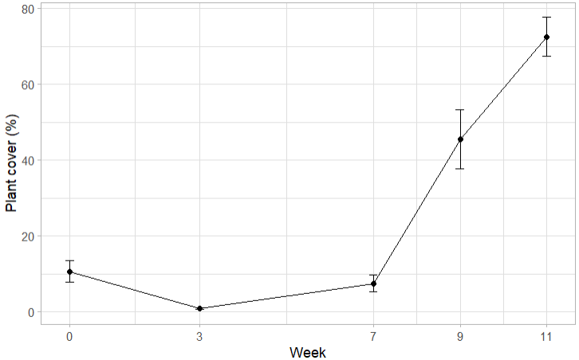

**Figure 2**: Percentage ground cover of plants on each plot at every survey week. Week 0 is a pre-spray, while weeks 3-11 are post-sprays.Error bars are S.E.Ms

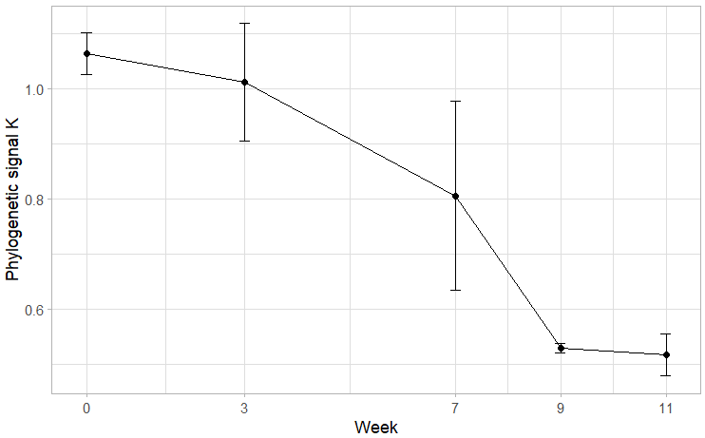

**Figure 3**: Phylogenetic signal (Bloomberg K values) of plants on each plot at every survey week. Week 0 is a pre-spray period, while weeks 3-11 are post-spray periods. Error bars are S.E.Ms

An orthogonal polynomial mixed-effects model was used to assess the relationship between phylogenetic signal and plant ground cover, incorporating a quadratic term to account for potential nonlinear effects. The linear term for ground cover was significantly negative (β = -0.59, SE = 0.225, p <0.001), suggesting that the phylogenetic signal decreased as plant ground cover increased. However, the quadratic term was marginally significant (β = 0.46, SE = 0.229, p <0.01), indicating a possible nonlinear relationship, where the phylogenetic signal may initially decline but later stabilize or slightly increase at higher ground cover levels (Figure 4).

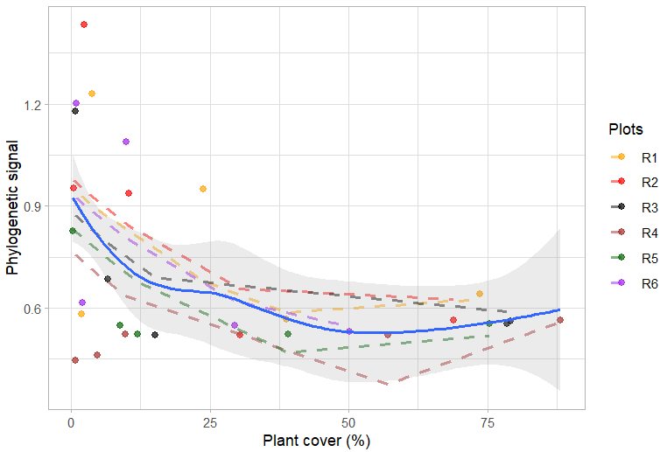

**Figure 4**: Relationship between (strength of) phylogenetic signal and plant cover (%). Each broken line indicates a replicate. The general trend in phylogenetic signal is coloured in blue.

**DISCUSSION**

This study demonstrates that herbicide application did not significantly alter the phylogenetic signal of the plant community. Despite an initial sharp decline in plant cover following herbicide treatment, species recovery was rapid, suggesting that external environmental factors play a major role in facilitating regrowth. The study area, Benin, is known to have its wet season beginning in April, and this must have caused the exponential increase in the plant’s ground cover.

A key finding of this study is the significant increase in plant cover over time, accompanied by a decline in phylogenetic signal during the later weeks of recovery. This pattern is suggestive of a support for the competition-relatedness hypothesis (Darwin, 1859; Violle et al., 2011), which posits that closely related species compete more intensely due to their ecological similarity. As plant cover increased, competition for space and light intensified, likely favouring species with greater competitive ability rather than those that simply survived the herbicide. The observed phylogenetic divergence suggests that competition, rather than herbicide tolerance, was the primary driver of community assembly in the latter stages of the study.

The findings from this study have important implications for sustainable agroecosystems, particularly in weed management strategies that incorporate herbicide use. The role of competitive interactions in shaping plant community responses to herbicides warrants further investigation. For example, Boutin et al. (2019) demonstrated that competition influences plant responses to herbicides, showing that competitive interactions triggered significant changes in the response of plant species to sub-lethal doses of glyphosate and metsulfuron-methyl herbicides. These findings highlight the need to incorporate species interactions, such as competition, into ecological risk assessments of herbicides. Furthermore, Menalled et al. (2023) explored the competition exclusion principle for weed management, emphasizing the potential of cover crops in reducing reliance on herbicides and tillage. Similarly, Levin et al. (2020) found that phylogenetically distinct species tend to compete less with their local communities, though this effect diminishes at larger spatial scales. They suggested that integrating functional traits alongside phylogenetic relationships could improve predictions of plant responses to competition.

**Limitations and Future Studies**

One limitation of this study is the potential impact of species turnover. While the phylogenetic signal remained stable before and shortly after herbicide application, turnover in species composition during the later recovery phase may have influenced competitive dynamics and driven the observed trend towards phylogenetic divergence. Future studies should incorporate finer-scale tracking of individual plant species to assess how turnover contributes to shifts in phylogenetic structure. Additionally, because this study was conducted in an unmanaged lawn rather than a controlled experimental setting, it remains unclear whether certain phenotypic traits—such as growth form, phototropism, or leaf structure—conferred a competitive advantage independent of phylogenetic relatedness. Future research integrating functional traits with phylogenetic analyses would help disentangle the relative contributions of evolutionary history and ecological strategies in determining plant survival and competitive success.

**CONCLUSION**

This study supports Darwin’s competitive exclusion principle, demonstrating that competition among closely related species can lead to phylogenetic divergence in a recovering plant community. While herbicide application significantly reduced plant cover, it did not alter phylogenetic signal immediately post-spray. Instead, as plants recovered, competitive interactions favoured the persistence of more distantly related species, leading to a decline in phylogenetic signal over time. These findings highlight the importance of competition in shaping plant community assembly after disturbance, emphasizing the need for integrated approaches that consider both evolutionary history and functional traits in ecological management and conservation.

**REFERENCES**

Abrams, P. (1983). The theory of limiting similarity. *Annual review of ecology and systematics*, *14*, 359-376.

Adejuwon, J. O., & Odekunle, T. O. (2006). Variability and the Severity of the “little Dry Season” in southwestern Nigeria. Journal of climate, 19(3), 483-493.

Alberti, M. (2015). Eco-evolutionary dynamics in an urbanizing planet. Trends in ecology & evolution, 30(2), 114-126.

Anderson, E. W. (1986). A guide for estimating cover.

Boutin, C., Montroy, K., Mathiassen, S. K., Carpenter, D. J., Strandberg, B., & Damgaard, C. (2019). Effects of sublethal doses of herbicides on the competitive interactions between 2 nontarget plants, Centaurea cyanus L. and Silene noctiflora L. *Environmental Toxicology and Chemistry*, *38*(9), 2053-2064.

Briggs, E.L., Greene, D.U., Fortuin, C.C., Clabo, D.C., Barnes, B.F., Gandhi, K.J.K. (2025). Understory plant community responses following herbicide application in loblolly pine (Pinus taeda L.) stands. Forest Ecology and Management 585, 122617.

Burns, J. H., & Strauss, S. Y. (2011). More closely related species are more ecologically similar in an experimental test. Proceedings of the National Academy of Sciences, 108(13), 5302-5307.

Cavender-Bares, J., & Reich, P. B. (2012). Shocks to the system: community assembly of the oak savanna in a 40‐year fire frequency experiment. *Ecology*, *93*(sp8), S52-S69.

Damgaard, C. (2011). Measuring competition in plant communities where it is difficult to distinguish individual plants. *Computational Ecology and Software*, *1*(3), 125-137.

Damgaard, C. (2011). Measuring competition in plant communities where it is difficult to distinguish individual plants. *Computational Ecology and Software*, *1*(3), 125-137.

Darwin, C. (1859). On the Origin of Species by Means of Natural Selection. J. Murray, London.

Délye, C., Jasieniuk, M., & Le Corre, V. (2013). Deciphering the evolution of herbicide resistance in weeds. Trends in Genetics, 29(11), 649-658.

Fritschie, K. J., Cardinale, B. J., Alexandrou, M. A., & Oakley, T. H. (2014). Evolutionary history and the strength of species interactions: testing the phylogenetic limiting similarity hypothesis. Ecology, 95(5), 1407-1417.

Germain, R. M., Weir, J. T., & Gilbert, B. (2016). Species coexistence: macroevolutionary relationships and the contingency of historical interactions. *Proceedings of the Royal Society B: Biological Sciences*, *283*(1827), 20160047.

Gibson, D. J., Shupert, L. A., & Liu, X. (2019). Do no harm: efficacy of a single herbicide application to control an invasive shrub while minimizing collateral damage to native species. Plants, 8(10), 426.

Godoy, O., Kraft, N. J., & Levine, J. M. (2014). Phylogenetic relatedness and the determinants of competitive outcomes. *Ecology letters*, *17*(7), 836-844.

Gratani, L. (2014). Plant phenotypic plasticity in response to environmental factors. *Advances in botany*, *2014*(1), 208747.

Gratani, L. (2014). Plant phenotypic plasticity in response to environmental factors. *Advances in botany*, *2014*(1), 208747.

Grundy, A. C., Mead, A., Bond, W., Clark, G., & Burston, S. (2011). The impact of herbicide management on long‐term changes in the diversity and species composition of weed populations. *Weed Research*, *51*(2), 187-200.

Hardin, G. (1960). The competitive exclusion principle: an idea that took a century to be born has implications in ecology, economics, and genetics. *science*, *131*(3409), 1292-1297.

Helmus, M. R., Keller, W., Paterson, M. J., Yan, N. D., Cannon, C. H., & Rusak, J. A. (2010). Communities contain closely related species during ecosystem disturbance. Ecology letters, Violle, C., Nemergut, D. R., Pu, Z., & Jiang, L. (2011). Phylogenetic limiting similarity and competitive exclusion. Ecology letters, 14(8), 782-787.

Iriart, V., Baucom, R. S., & Ashman, T. L. (2021). Herbicides as anthropogenic drivers of eco‐evo feedbacks in plant communities at the agro‐ecological interface. Molecular Ecology, 30(21), 5406-5421.

Jaeger, R. G. (1974). Competitive exclusion: comments on survival and extinction of species. *BioScience*, *24*(1), 33-39.

Jin, Y., & Qian, H. (2019). V. PhyloMaker: an R package that can generate very large phylogenies for vascular plants. *Ecography*, *42*(8), 1353-1359.

Johnson, C. A., & Bronstein, J. L. (2019). Coexistence and competitive exclusion in mutualism.

Kumordzi, B. B., Wardle, D. A., & Freschet, G. T. (2015). Plant assemblages do not respond homogenously to local variation in environmental conditions: functional responses differ with species identity and abundance. *Journal of Vegetation Science*, *26*(1), 32-45.

Lemos‐Costa, P., Miller, Z. R., & Allesina, S. (2024). Phylogeny structures species' interactions in experimental ecological communities. *Ecology Letters*, *27*(8), e14490.

Levin, S. C., Crandall, R. M., Pokoski, T., Stein, C., & Knight, T. M. (2020). Phylogenetic and functional distinctiveness explain alien plant population responses to competition. *Proceedings of the Royal Society B*, *287*(1930), 20201070.

Losos, J. B. (2008). Phylogenetic niche conservatism, phylogenetic signal and the relationship between phylogenetic relatedness and ecological similarity among species. *Ecology letters*, *11*(10), 995-1003.

Lovette, I. J., & Hochachka, W. M. (2006). Simultaneous effects of phylogenetic niche conservatism and competition on avian community structure. *Ecology*, *87*(sp7), S14-S28.

MacArthur, R. & Levins, R. (1967). The limiting similarity, convergence, and divergence of coexisting species. Am. Nat., 101, 377–385.

Manish, K. (2021). Species richness, phylogenetic diversity and phylogenetic structure patterns of exotic and native plants along an elevational gradient in the Himalaya. Ecological Processes, 10, 1-13.

Menalled, U. D., Smith, R. G., Cordeau, S., DiTommaso, A., Pethybridge, S. J., & Ryan, M. R. (2023). Phylogenetic relatedness can influence cover crop-based weed suppression. Scientific Reports, 13(1), 17323.

Naughton, H. R., Alexandrou, M. A., Oakley, T. H., & Cardinale, B. J. (2015). Phylogenetic distance does not predict competition in green algal communities. Ecosphere, 6(7), 1-19.

Pellissier, L., Wisz, M. S., Strandberg, B., & Damgaard, C. (2014). Herbicide and fertilizers promote analogous phylogenetic responses but opposite functional responses in plant communities. *Environmental Research Letters*, *9*(2), 024016.

Powles, S. B., & Yu, Q. (2010). Evolution in action: plants resistant to herbicides. *Annual review of plant biology*, *61*(1), 317-347.

Qian, H., & Sandel, B. (2017). Phylogenetic relatedness of native and exotic plants along climate gradients in California, USA. Diversity and Distributions, 23(11), 1323-1333.

Schoener, T. W. (2011). The newest synthesis: understanding the interplay of evolutionary and ecological dynamics. *science*, *331*(6016), 426-429.

Wang, C., Lin, X., Li, L., & Lin, S. (2016). Differential growth responses of marine phytoplankton to herbicide glyphosate. PloS one, 11(3), e0151633.

Violle, C., Nemergut, D. R., Pu, Z., & Jiang, L. (2011). Phylogenetic limiting similarity and competitive exclusion. *Ecology letters*, *14*(8), 782-787.

Zepeda, V., & Martorell, C. (2021). Effects of phylogenetic relatedness on fluctuation-dependent and fluctuation-independent coexistence mechanisms in multispecies communities. *The American Naturalist*, *198*(1), E1-E11.